Lab 5

Murtaza ali qazi(2112120)&  
Sabih ul hassan(2112126)

DEVOPS

SZABIST KARACHI

Task1

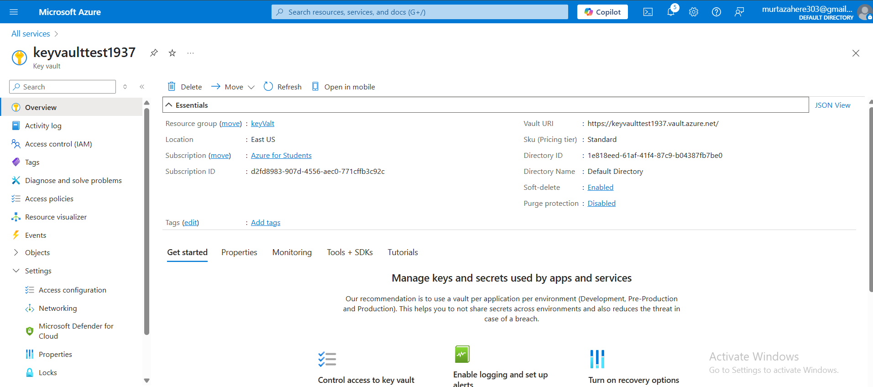

Task2

